|  |
| --- |
| APTECH APROTRAIN |
| E-PROJECT 3 REPORT |
| Airline Reservation System |
|  |

|  |  |  |  |  |  |  |  |  |  |  |  |  |  |  |
| --- | --- | --- | --- | --- | --- | --- | --- | --- | --- | --- | --- | --- | --- | --- |
| |  |  |  | | --- | --- | --- | | Member | VU TRAN QUANG | Student1141700 | |  | KHOI NGUYEN DAM | Student1139856 | |  | LONG NGUYEN THE | Student1141702 | |  |  |  | |  |  |
|  |  |  |
|  |  |  |

|  |
| --- |
| Any information in this report which includes the content in this website is used for uncommercial purposes. |

**MENU**

**I.** **Introduction** 2

**1.** **Project information** 2

**2.** **Problem statement** 3

**3.** **Propose System** 3

**4.** **Hardware/ Software Requirements** 4

**II.** **Acknowledgements** 4

**III.** **Project Synopsis** 5

**IV.** **System Design** 6

**V.** **Screen shots at user’s client site** 18

1. **Search flight** 18

VI. **Screen shot of Admin’s site** (Admin – 123) 21

**VII.** **Source Code:** 24

**VIII.** **Task Sheet:** 24

1. **Introduction**
2. **Project information**

Project name: Airline Reservation System

Project type: Website

Timeline: from 16-Oct-2020 to 14-Nov-2020

1. **Problem statement**

* The Airline Reservation System (ARS) is a software application to assist an airline with transactions related to making ticket reservations, which includes blocking, reserving, canceling and rescheduling tickets.
* From the viewpoint of the airlines -
* Minimize repetitive work done by the system administrator and reservation clerks.
* The users should be basically taken through the same steps by the system as they go through in conventional desk-reservation systems.
* Maintain customer information in case of emergency, e.g. flight cancellation due to inclement weather. The profile can also be used by the airline company to track user preferences and travel patterns to serve them better, plan routes, for better marketing and efficient scheduling of flights.
* Maximize the revenue of the airline company by various means:
* Increase awareness among frequent travelers about various special offers and discounts.
* Minimize the number of vacant seats on a flight and maximize flight capacity utilization.
* Maintain the capability to adopt a flexible pricing policy. The price of the tickets should be dynamically determined based on how early, before the date of departure, the customer buys the ticket.
* A survey conducted by airline companies shows that users of an existing reservation system would respond favorably to an ARS that satisfied or helped them satisfy the following objectives:
* Reduce effort and frustration for travelers in scheduling a trip, especially by reducing the search effort for the flight they need to take.
* Show all possible combinations and itineraries available for a pair of origin-destination cities.
* Reduce redundancy in the information required from the customers in order for them to buy tickets, create user accounts etc.
* Check the validity of input data and give a feedback to the user in case of errors or inconsistency.
* Make it easy for travelers to check the ticket status or make changes to their trip.

1. **Propose System**

* User Accounts
* Registration and creation of user profile
* Checking Availability
* Making Reservations/Blocking/Confirmation
* Confirm Ticket
* Reschedule Ticket
* Cancellation
* Update Profile
* View Ticket Status
* Query Flight Details

1. **H****ardware/ Software Requirements**

**Hardware**

* A minimum computer system that will help you access all the tools in the courses is a Pentium 166 or better
* 64 Megabytes of RAM or better

**Software**

* Visual studio 2017
* Microsoft SQL Server Management Studio 2018

1. **Acknowledgements**

We would like to send our sincere thanks to:

- The Aptech training system has provided the topic as well as support in many aspects of our project process.

- Faculty Phong Tieu Ha, who had given us a lot of support, guidance, motivation throughout the project, from the beginning till the very end.

1. **Project Synopsis**

This website’s purpose is to:

* Checking flight availability
* Making a flight reservations/blocking/confirmation
* Confirm purchasing ticket
* Reschedule ticket
* Ticket cancellation

The interface for visitors has a robust search engine, allowing visitor to search for a flight of their choice.

Visitor can book a one way flight or round trip flights

After booking fight, visitor can search for the order to check the flight information.

Visitor can also cancel order after booking a ticket

Website also have separate administration interface. Administration interface have many function which help managers to add/edit/delete the information in website. Moreover, administration can view customer information and orders.

1. **System Design**

**Database design**

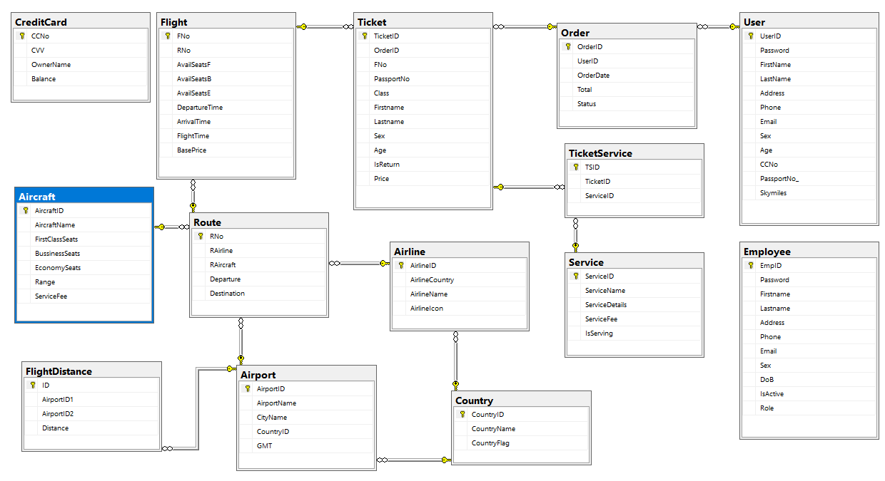

**Table’s details**

Table ‘**Aircraft’**

|  |  |  |  |
| --- | --- | --- | --- |
| **Column** | **Data type** | **Constraint** | **Description** |
| ` AircraftID ` | varchar(50) | NOT NULL  PRIMARY KEY | Unique ID to define aircraft |
| ` AircraftName` | NVARCHAR(100) | NOT NULL | Name of each aircraft |
| ` FirstClassSeats` | int | NULL | Number of first class seats |
| BussinessSeats | int | NULL | Number of business class seats |
| EconomySeats | int | NOT NULL | Number of economy seats |
| Range | int | NOT NULL | Flight distance that aircraft can fly |

Table **`Country`**

|  |  |  |  |
| --- | --- | --- | --- |
| **Column** | **Data type** | **Constraint** | **Description** |
| CountryID | varchar(10) | PRIMARY KEY  NOT NULL | Unique ID to define each **Country** |
| CountryName | nvarchar(100) | NOT NULL | Name of **Country** |
| CountryFlag | nvarchar(100) | NOT NULL | Link to the image folder that contains flag image |

Table **‘Airline’**

|  |  |  |  |  |
| --- | --- | --- | --- | --- |
| **Column** | **Data type** | **Constraint** | **Description** | |
| AirlineID | varchar(10) | NOT NULL PRIMARY KEY | Unique ID to define each **Airline** | |
| AirlineCountry | varchar(10) | NOT NULL  FOREIGN KEY | CountryID of the country which the airline belongs to | |
| AirlineName | varchar(60) | NOT NULL | Name of airline |
| AirlineIcon | varchar(100) | NULL | Link to the image folder that contains airline icon image |

Table ‘**Airport**’

|  |  |  |  |
| --- | --- | --- | --- |
| **Column** | **Data type** | **Constraint** | **Description** |
| AirportID | varchar(10) | NOT NULL  PRIMARY KEY | Unique ID to define each advertisement |
| AirportName | varchar(60) | NOT NULL | Airport name |
| CityName | nvarchar(60) | NOT NULL | Name of the City |
| CountryID | varchar(10) | NOT NULL  FOREIGN KEY | Country ID of country which airport belongs to |
| GMT | float | NOT NULL | CMT time |

Table ‘**Route**’

|  |  |  |  |
| --- | --- | --- | --- |
| **Column** | **Data type** | **Constraint** | **Description** |
| RNo | bigint | IDENTITY(1,1)  PRIMARY KEY  NOT NULL | Route ID |
| RAirline | varchar(10) | NOT NULL  FOREIGN KEY | Airline ID of airline which flies this route |
| RAircraft | varchar(50) | NOT NULL  FOREIGN KEY | Aircraft ID of aircraft which flies this route |
| Departure | varchar(10) | NOT NULL  FOREIGN KEY | Airport ID of airport which is beginning point of this route |
| Destination | varchar(10) | NOT NULL  FOREIGN KEY | Airport ID of airport which is the end point of this route |

Table ‘**Flight**’

|  |  |  |  |
| --- | --- | --- | --- |
| **Column** | **Data type** | **Constraint** | **Description** |
| FNo | varchar(10) | NOT NULL  PRIMARY KEY | Unique ID to define flight |
| RNo | bigint | NOT NULL  FOREIGN KEY | Route ID of route that the flight belong to |
| AvailSeatsF | int | NULL | Number of first class seat available in a flight |
| AvailSeatsB | int | NULL | Number of business class seat available in a flight |
| AvailSeatsE | int | NOT NULL | Number of economy class seat available in a flight |
| DepartureTime | datetime | NOT NULL | Time when flight departures |
| ArrivalTime | datetime | NOT NULL | Time when flight arrives |
| FlightTime | float | NOT NULL | Total amount of time that the flight taes |
| BasePrice | float | NOT NULL | Price for the flight |

Table ‘**FlightDistance**’

|  |  |  |  |
| --- | --- | --- | --- |
| **Column** | **Data type** | **Constraint** | **Description** |
| ID | int | NOT NULL IDENTITY(1,1)  PRIMARY KEY | Unique ID to define the flight distance between two airports |
| AirportID1 | varchar(10) | NOT NULL  FOREIGN KEY | Airport ID of the first aiport |
| AirportID2 | varchar(10) | NOT NULL  FOREIGN KEY | Airport ID of the second aiport |
| Distance | int | NOT NULL | Distance between two airport |

Table ‘**User**’

|  |  |  |  |
| --- | --- | --- | --- |
| **Column** | **Data type** | **Constraint** | **Description** |
| UserID | varchar(50) | NOT NULL  PRIMARY KEY | Unique ID to define user |
| Password | nvarchar(256) | NOT NULL | Password of user account |
| FirstName | nvarchar(50) | NOT NULL | First name |
| LastName | nvarchar(50) | NOT NULL | Last name |
| Address | nvarchar(200) | NOT NULL | Address |
| Phone | varchar(12) | NOT NULL | Phone number |
| Email | varchar(256) | NOT NULL | Email |
| Sex | bit | NOT NULL | Sex  1 is male  2 is female |
| Age | int | NOT NULL | Age |
| CCNo | varchar(12) | NOT NULL | Credit card number |
| PassportNo | varchar(10) | NOT NULL | Passport number |

Table ‘**Order**’

|  |  |  |  |
| --- | --- | --- | --- |
| **Column** | **Data type** | **Constraint** | **Description** |
| OrderID | bigint | NOT NULL  PRIMARY KEY | Unique ID to define order |
| UserID | varchar(50) | NOT NULL  FOREIGN KEY | User ID of user who placed order |
| OrderDate | datetime | NOT NULL | Date at which order was placed |
| Total | float | NOT NULL | Total amount user has to pay |
| Status | int | NOT NULL | Order status  1 is Booked  2 is Canceled |

Table ‘**Ticket**’

|  |  |  |  |
| --- | --- | --- | --- |
| **Column** | **Data type** | **Constraint** | **Description** |
| TicketID | bigint | NOT NULL  PRIMARY KEY | Unique ID to define ticket |
| OrderID | bigint | NOT NULL  FOREIGN KEY | Order ID of order which ticket belongs to |
| FNo | varchar(10) | NOT NULL  FOREIGN KEY | Flight ID of flight which ticket belong to |
| PassportNo | varchar(1) | NOT NULL | Passport number of user |
| Class | nvarchar(50) | NOT NULL | Travel class that user purchase:  E is economy  B is business  F is first class |
| Firstname | nvarchar(50) | NOT NULL | First name |
| Lastname | nvarchar(50) | NOT NULL | Last name |
| Sex | bit | NOT NULL | Sex |
| Age | int | NOT NULL | Age |
| IsReturn | bit | NOT NULL | Is it round trip |
| Price | float | NOT NULL | Total price for ticket |

Table ‘**CreditCard**’

|  |  |  |  |
| --- | --- | --- | --- |
| **Column** | **Data type** | **Constraint** | **Description** |
| CCNo | varchar(12) | NOT NULL  PRIMARY KEY | Credit card number |
| CVV | varchar(3) | NOT NULL | Card security code |
| OwnerName | varchar(100) | NOT NULL | Name of credit card owner |
| Balance | float | NOT NULL | Card balance |

Table ‘**Employee**’

|  |  |  |  |
| --- | --- | --- | --- |
| **Column** | **Data type** | **Constraint** | **Description** |
| EmpID | varchar(50) | NOT NULL  PRIMARY KEY | Unique ID to define employee |
| Password | nvarchar(256) | NOT NULL | Password for employee account |
| Firstname | nvarchar(50) | NOT NULL | First name |
| Lastname | nvarchar(50) | NOT NULL | Last name |
| Address | nvarchar(200) | NOT NULL | Address |
| Phone | varchar(12) | NOT NULL | Phone number |
| Email | varchar(256) | NOT NULL | Email |
| Sex | bit | NOT NULL | Sex |
| DoB | datetime | NOT NULL | Date of birth |
| IsActive | bit | NOT NULL | Is account active? |
| Role | int | NOT NULL | Employee role  0 is Admin  1 is Clerk |

Table ‘**Service**’

|  |  |  |  |
| --- | --- | --- | --- |
| **Column** | **Data type** | **Constraint** | **Description** |
| ServiceID | varchar(10) | NOT NULL  PRIMARY KEY | Unique ID to define service |
| ServiceName | nvarchar(100) | NOT NULL | Service name |
| ServiceDetails | nvarchar(MAX) | NOT NULL | Detail of service |
| ServiceFee | float | NOT NULL | Fee |
| IsServing | bit |  | Service avalability |

Table ‘**TicketService’**

|  |  |  |  |
| --- | --- | --- | --- |
| **Column** | **Data type** | **Constraint** | **Description** |
| TSID | int | NOT NULL  PRIMARY KEY  IDENTITY (1,1) | Unique ID to define service that goes with purchased ticket |
| TicketID | bigint | NOT NULL  FOREIGN KEY | Ticket ID |
| ServiceID | varchar(10) | NOT NULL  FOREIGN KEY | Service ID of service that belongs to this ticet service |

**User Diagram**



**Employee Diagram**



1. **Screen shots at user’s client site**

**Search flight**

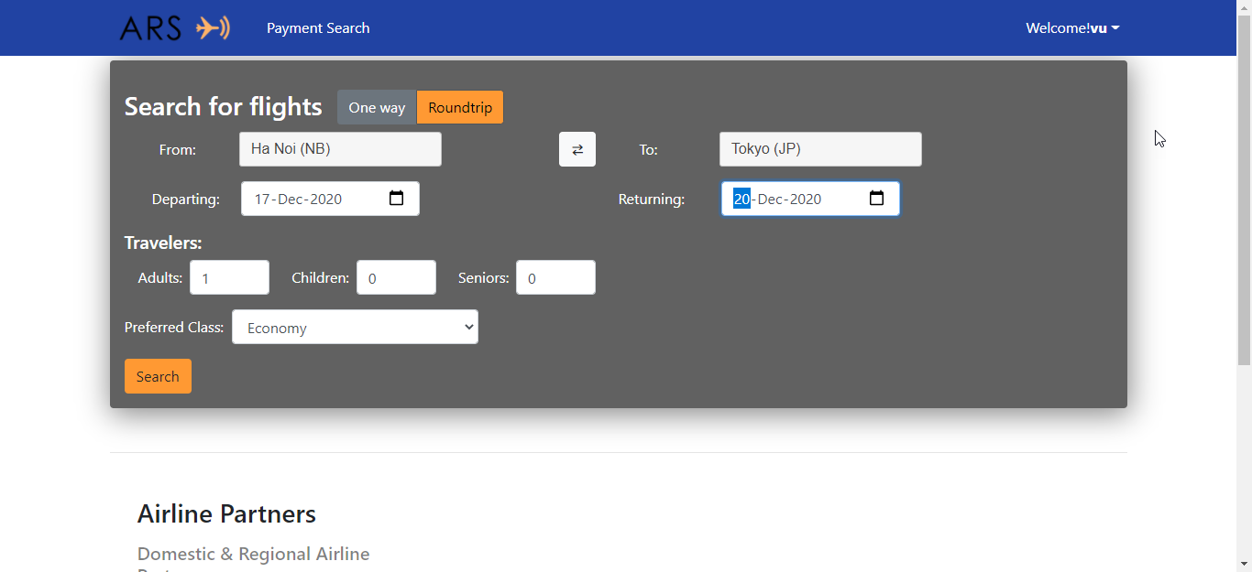

**Flight search result**

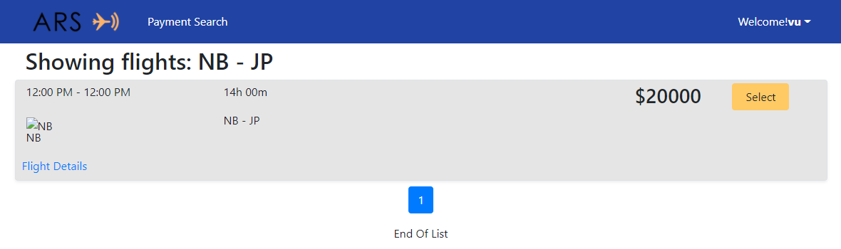

**Flight booking detail**

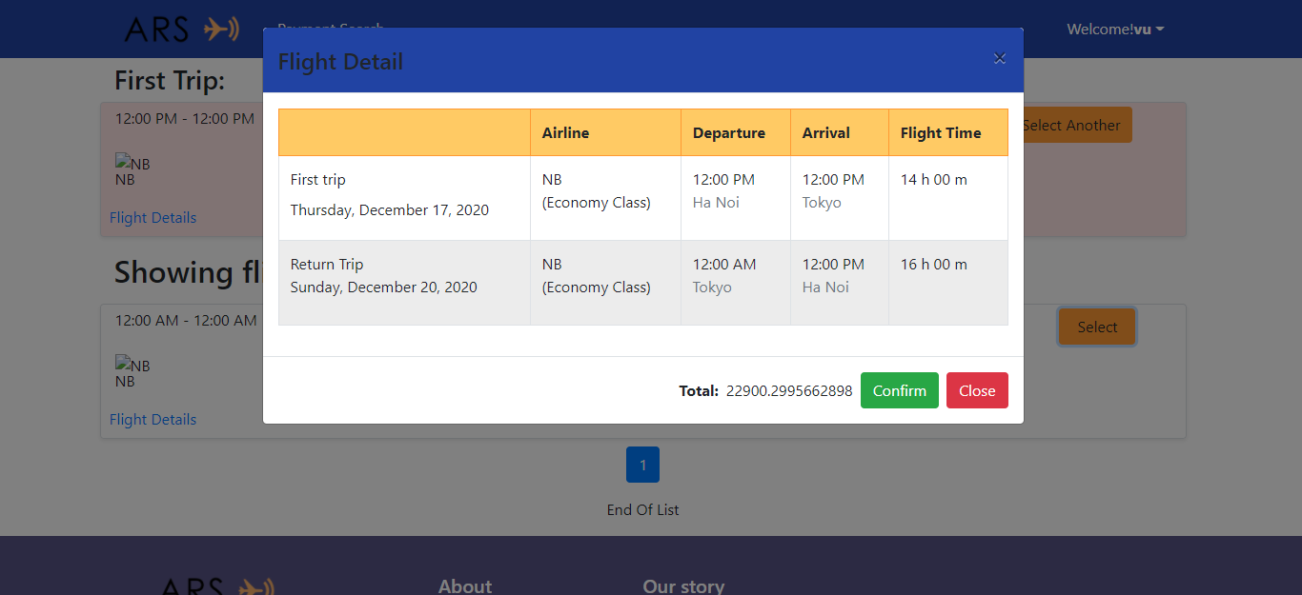

**Checkout and Payment**

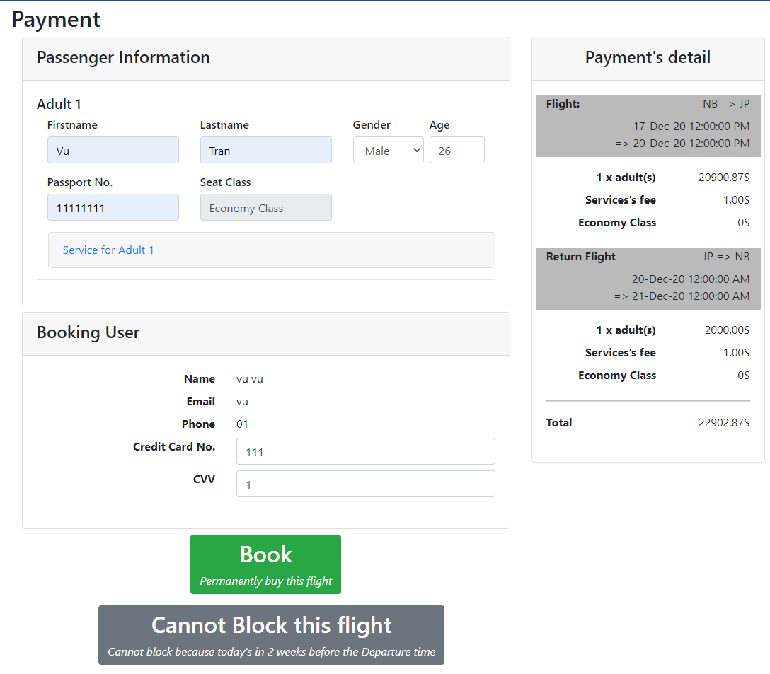

**Booking success**

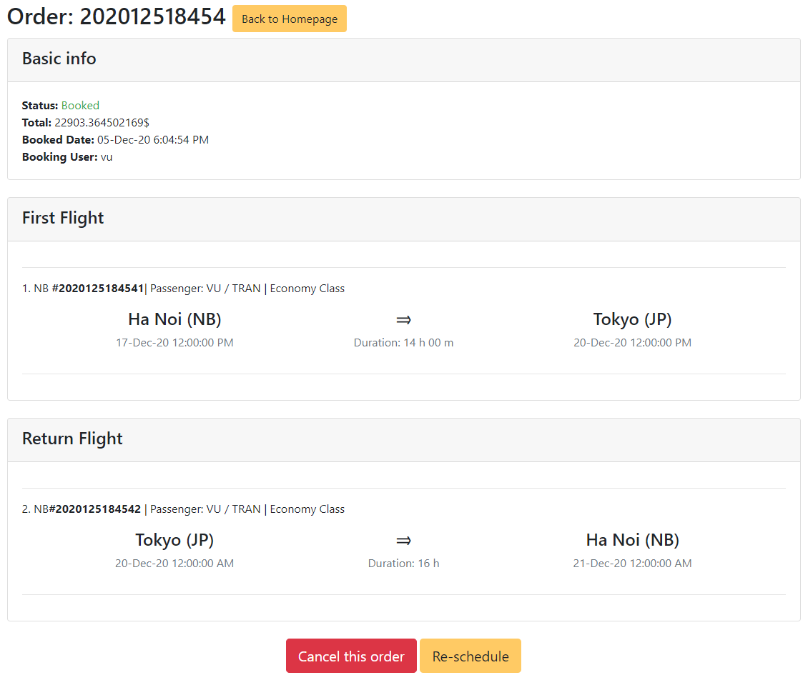

**Cancel order**

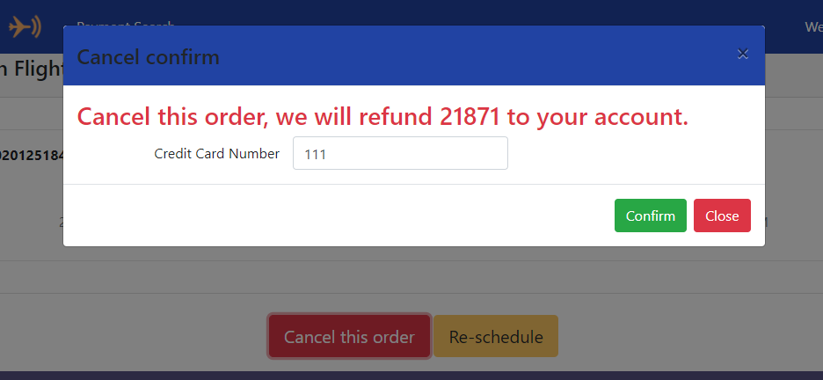

1. **Screen shot of Admin’s site** (Admin – 123)

**Login**

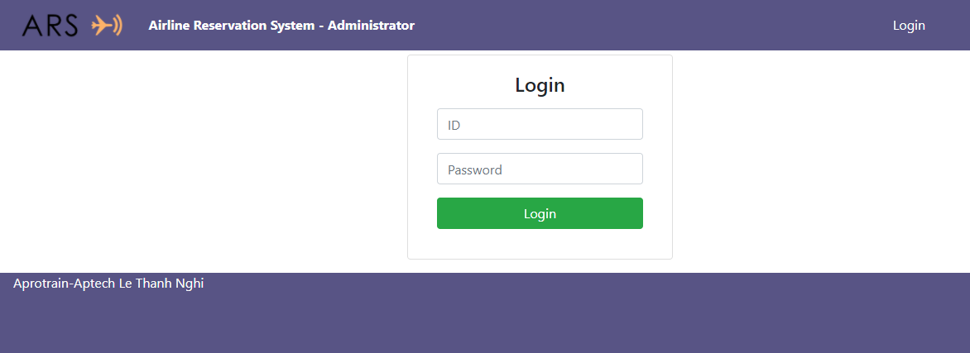

**Manage route**

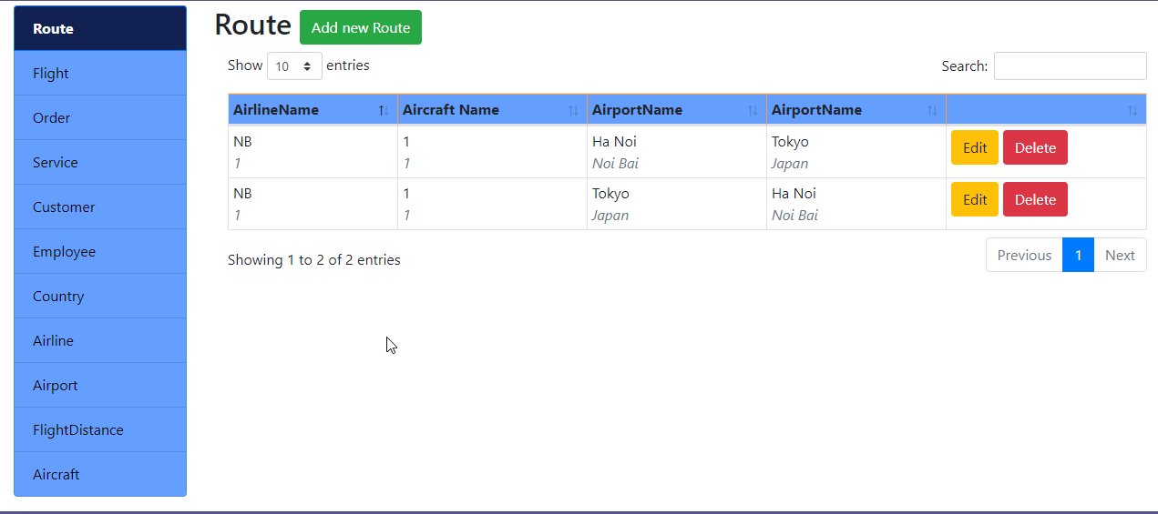

**Manage flight**

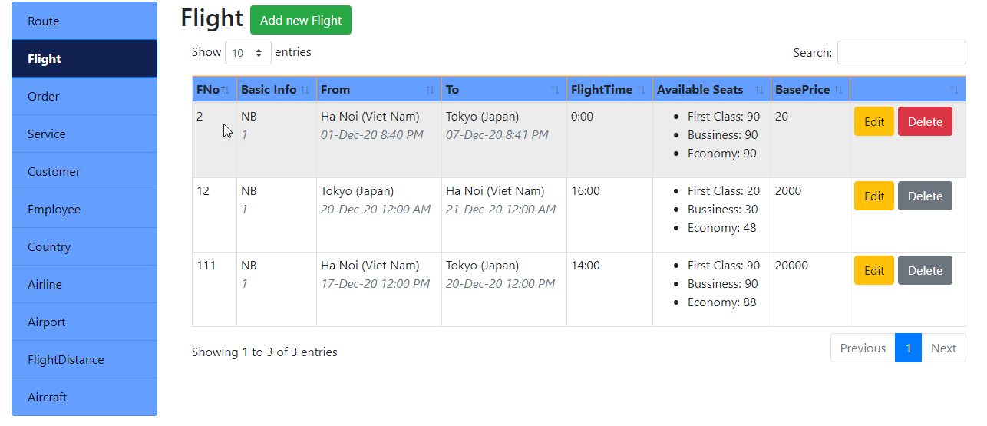

**Manage order**

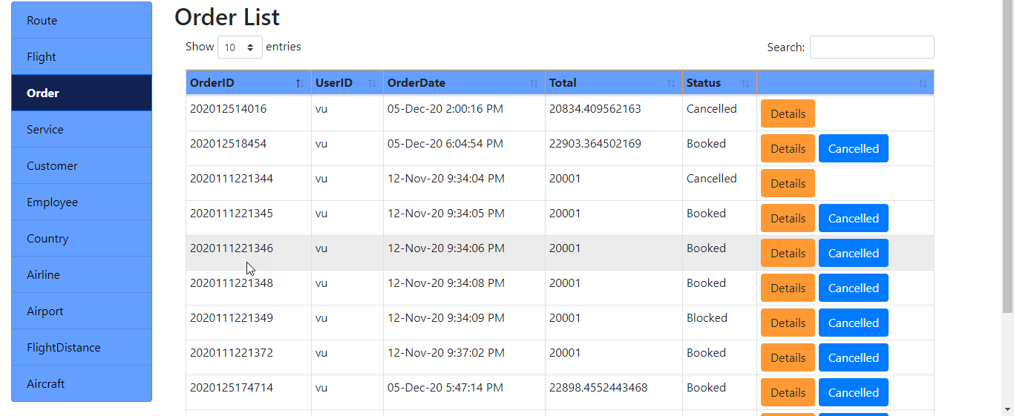

**Manager service**

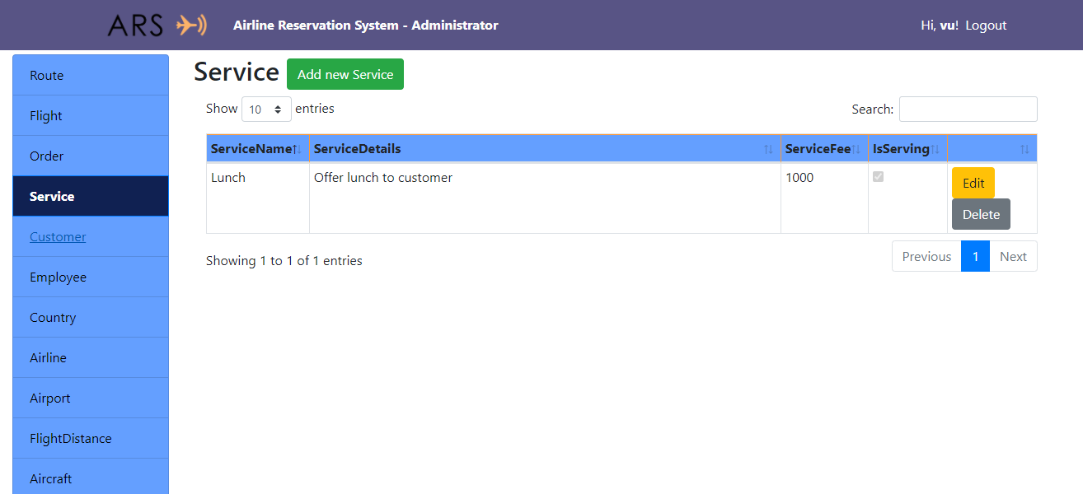

**Manage Customer**

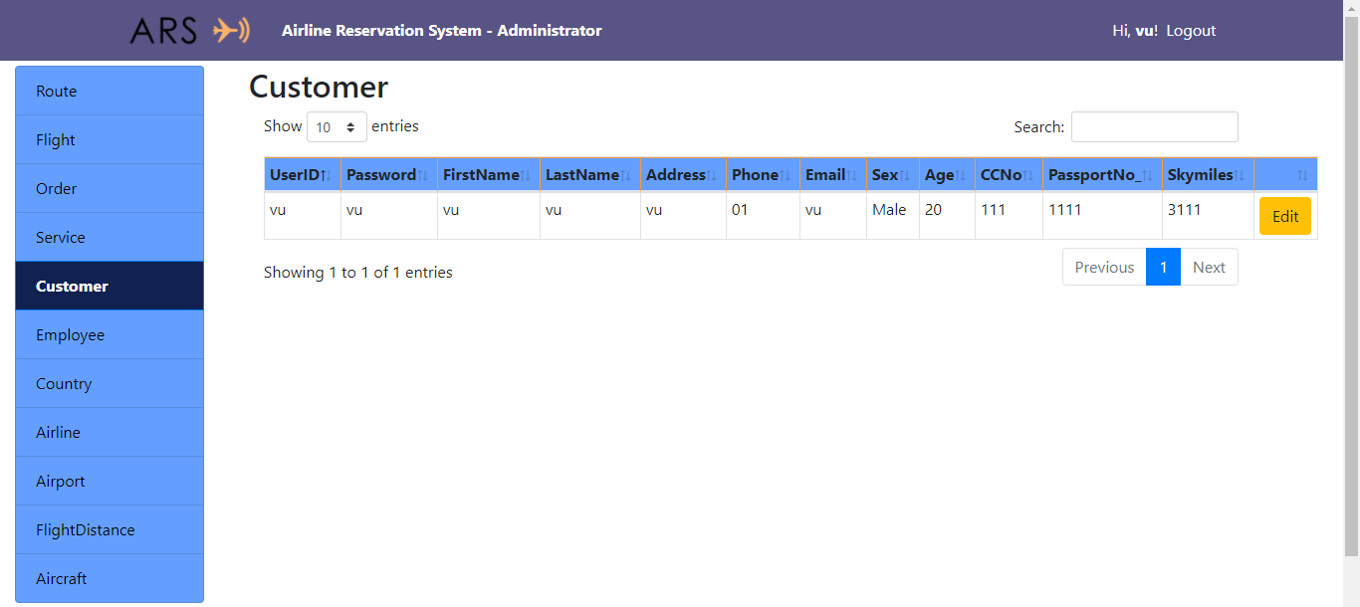

**Manage employee**

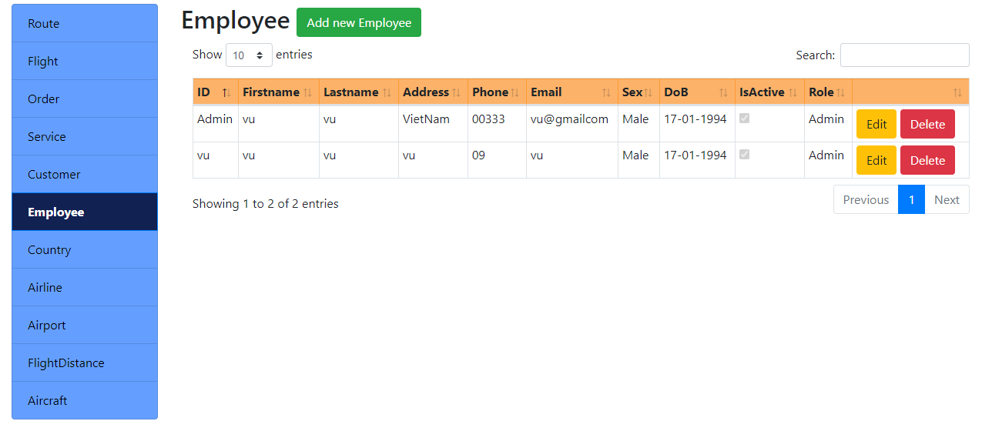

**Manage Country**

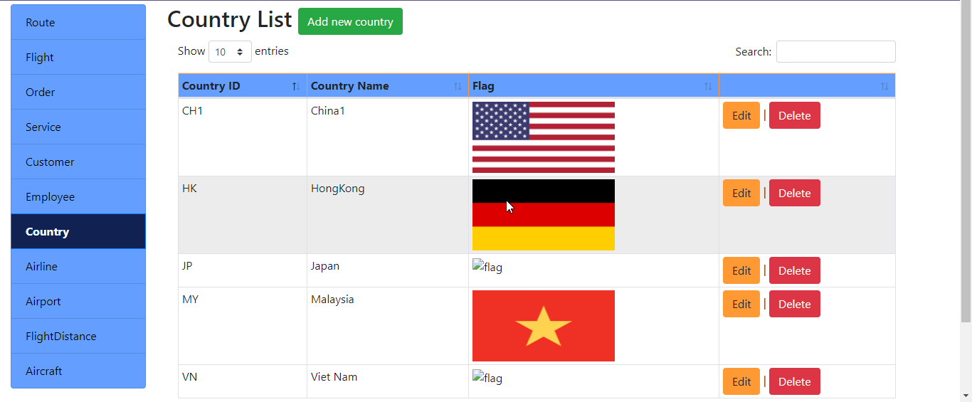

1. **Source Code:**

All parts of our project source code have been compressed and uploaded to google drive under the link below. Please download the link.

1. **Task Sheet:**

|  |  |  |  |  |
| --- | --- | --- | --- | --- |
| Task | Start time | Finish time | Implemented by | Evaluation(%) |
| Feasibility study phase |  |  |  |  |
| Evaluate and analyze idea | 16/10/2020 | 20/10/2020 | VU TRAN QUANG | 30 |
| Provide opinions and idea | 16/10/2019 | 20/10/2020 | KHOI NGUYEN DAM | 25 |
| Provide opinions and idea | 16/10/2019 | 20/10/2020 | LONG NGUYEN THE | 25 |
| Approve and finalize idea | 20/10/2020 | 23/10/2020 | VU TRAN QUANG | 20 |
| Requirement Analysis phase |  |  |  |  |
| Propose system | 23/10/2020 | 25/10/2020 | KHOI NGUYEN DAM | 50 |
| Analyze and approve final system | 25/10/2020 | 27/10/2020 | VU TRAN QUANG | 50 |
| Design phase |  |  |  |  |
| Design Database | 28/10/2020 | 3/11/2020 | VU TRAN QUANG | 50 |
| Design basic static client and admin | 28/10/2020 | 3/11/2020 | LONG NGUYEN THE | 50 |
| Development phase |  |  |  |  |
| Client site – Home Page | 3/11/2020 | 10/11/2020 | VU TRAN QUANG | 20 |
| Client site – Search, Order detail | 3/11/2020 | 11/11/2020 | LONG NGUYEN THE | 10 |
| Client site – Check out and payment | 11/11/2020 | 20/11/2020 | VU TRAN QUANG | 10 |
| Client site – Cancel and Reschedule | 3/11/2020 | 11/11/2020 | KHOI NGUYEN DAM | 10 |
| Admin site – Manage country, airline, aircraft, flight distance | 11/11/2020 | 22/11/2020 | KHOI NGUYEN DAM | 10 |
| Admin site – Manage route | 20/11/2020 | 28/11/2020 | VU TRAN QUANG | 20 |
| Admin site – – Manage flight, customer | 11/11/2020 | 22/11/2020 | LONG NGUYEN THE | 10 |
| Admin site – Manage employee | 22/11/2020 | 30/11/2020 | KHOI NGUYEN DAM | 10 |
| Testing phase – Delete page |  |  |  |  |
| Testing client site | 30/11/2020 | 02/12/2020 | KHOI NGUYEN DAM | 30 |
| Testing admin site | 30/11/2020 | 03/12/2020 | LONG NGUYEN THE | 30 |
| Final testing, fixing bugs | 30/11/2020 | 03/12/2020 | VU TRAN QUANG | 40 |
| Deployment phase |  |  |  |  |
| Analzye and approve final product | 03/12/2020 | 05/12/2020 | LONG NGUYEN THE | 50 |
| Write product report | 03/12/2020 | 05/12/2020 | VU TRAN QUANG | 50 |